Task already closed, move order still here

Select from apps.mtl_material_transactions_temp where TRX_SOURCE_LINE_ID=1138290
delete from apps.mtl_material_transactions_temp where TRX_SOURCE_LINE_ID=1138290
Pls delete it
-------------------
HI:
SB-05 的操作我们已作过，可还是无法成功删除。
Source header：266689 的身份已是CLOSE状态。
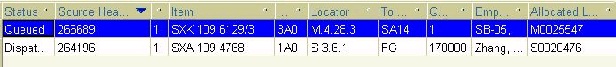
请帮忙在Oracle 内删除。
---------------
This task has beend loaded by SB-05.
Pls continue to do this task using SB-05 .In wms , task -current task , ctrl-l to select it .
If you want to continue this task , select Drop.
If you do not want to do it ,pls select Unloaded and cancel the Move orde lines .

BR//Li Jing
HI:

昨日发料时有一个Order无法picking 我已将系统数转到 SA14-A... 1PCS 请直接将这个Order删除。

Order号：266689

Hi :
夜班发料有个Order无法picking！请帮忙解决！谢谢！！！
From LPN :X360223
To Sub :SA14
Confirm >SA14
To Loc :SA14-A...
Confirm ]SA14-A...
<Done>
<Cancel>

|WMS_TD_PICK_DROP_FAIL|Error in Txn Manager
|Transaction p

